Expressive Vocabulary

🗣️ What is Expressive Vocabulary
# Source: AI Source: Provided by: [Data Path: Persons Table -> ID Column: 1, Name_En Column: Motasem Essam] -> From: [Chatgpt (GPT-4-turbo)] on [7/30/2025]
Expressive vocabulary refers to the words a person can actively produce and use in speaking or writing. It reflects how well someone can express ideas, thoughts, or feelings using language, and is a major component of productive vocabulary.

✅ Key Features:
# Source: AI Source: Provided by: [Data Path: Persons Table -> ID Column: 1, Name_En Column: Motasem Essam] -> From: [Chatgpt (GPT-4-turbo)] on [7/30/2025]
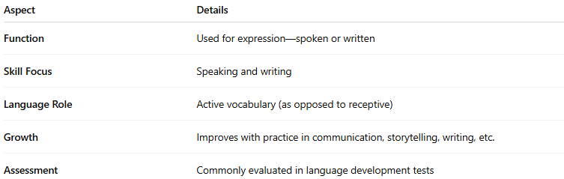
Aspect | Details
Function | Used for expression—spoken or written
Skill Focus | Speaking and writing
Language Role | Active vocabulary (as opposed to receptive)
Growth | Improves with practice in communication, storytelling, writing, etc.
Assessment | Commonly evaluated in language development tests

🧠 Examples:
# Source: AI Source: Provided by: [Data Path: Persons Table -> ID Column: 1, Name_En Column: Motasem Essam] -> From: [Chatgpt (GPT-4-turbo)] on [7/30/2025]
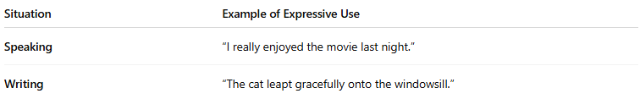
Situation | Example of Expressive Use
Speaking | “I really enjoyed the movie last night.”
Writing | “The cat leapt gracefully onto the windowsill.”
- Words like run, beautiful, because, quickly, and amazing are part of expressive vocabulary when used correctly by the speaker/writer.

👤 Who Uses It?
# Source: AI Source: Provided by: [Data Path: Persons Table -> ID Column: 1, Name_En Column: Motasem Essam] -> From: [Chatgpt (GPT-4-turbo)] on [7/30/2025]
- All language users (especially evaluated in children, ESL learners, or those with speech/language difficulties)
- Speech-language pathologists assess expressive vocabulary to diagnose or support development
- Educators focus on expanding expressive vocabulary to enhance students’ oral and written skills

📌 Related Vocabulary Types:
# Source: AI Source: Provided by: [Data Path: Persons Table -> ID Column: 1, Name_En Column: Motasem Essam] -> From: [Chatgpt (GPT-4-turbo)] on [7/30/2025]
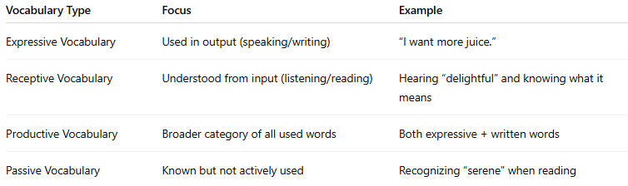
Vocabulary Type | Focus | Example
Expressive Vocabulary | Used in output (speaking/writing) | “I want more juice.”
Receptive Vocabulary | Understood from input (listening/reading) | Hearing “delightful” and knowing what it means
Productive Vocabulary | Broader category of all used words | Both expressive + written words
Passive Vocabulary | Known but not actively used | Recognizing “serene” when reading

